|  |  |
| --- | --- |
| Roles | Contributors |
| Lead Programmer | Bryan Bettis  Brian Sadowitz (In-Training) |
| Devices | Adam Sweiger |
| TeleOp | Jack Studier  Luke Herbert (Early design stages) |
| Auto – Task Control | Bryan Bettis  Holly Langenstein (Primarily on hardware team) |
| Auto - Navigation | Eamonn Ryan |
| Auto - Actions | Brian Sadowitz  Jack Studier |

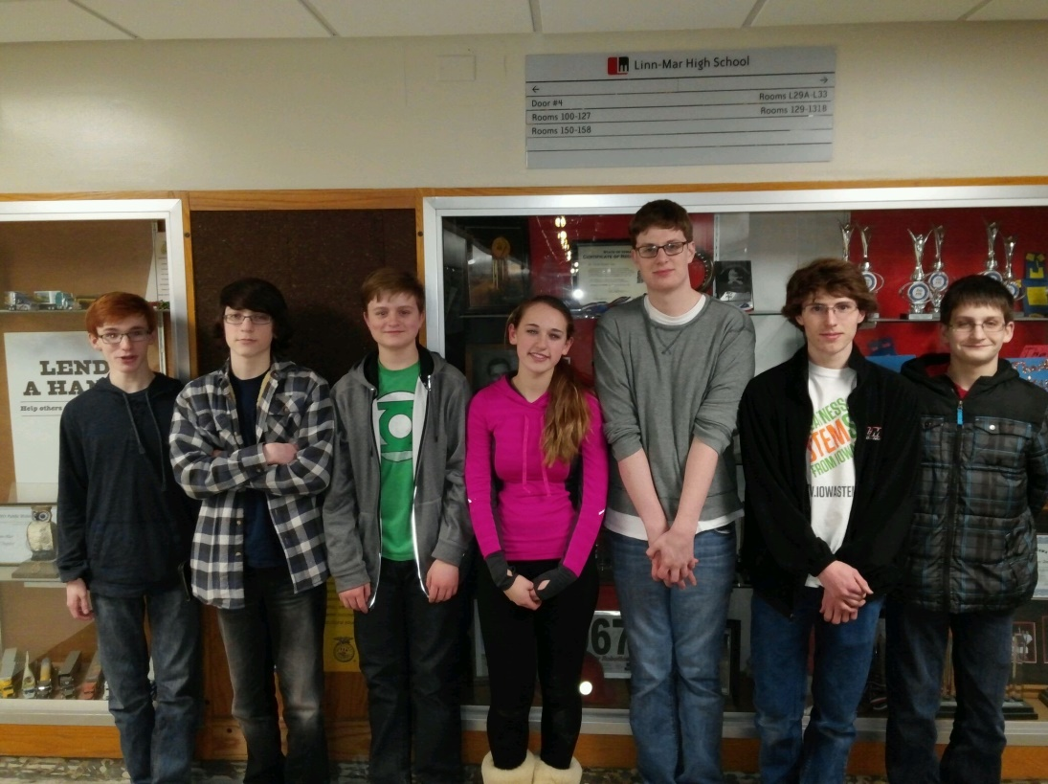

Left to right: Brian Sadowitz, Eamonn Ryan, Luke Herbert, Holly Langenstein, Jack Studier, Bryan Bettis, Adam Sweiger